Name_____________________________Period_____ 4.5 Dilations on a Coordinate Plane
Graph the Preimage and graph the Dilation using the scale factor listed in each problem.
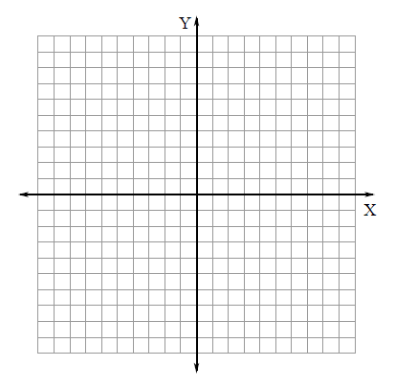
- Rectangle ABCD with vertices A(0,0), B(0,4), C(3,4), and D(3,0) DILATE with a scale factor of 2.
A( , ) A’( , )
B( , ) B’( , )
C( , ) C’( , )
D( , ) D’( , )
Length of AB___ A’B’____
Length of BC___ B’C’____
Length of CD___ C’D’____
Length of DA___ D’A’____
Perimeter of ABCD___ A’B’C’D’___
Area of ABCD____ A’B’C’D’____
Observations about points, sides, perimeters and areas.______________________________ ________________________________________________________________________________________________________________________________________________________

- Rectangle ABCD with vertices A(0,2), B(0,6), C(4,6), and D(4,2) DILATE with a scale factor of 1/2.
A( , ) A’( , )
B( , ) B’( , )
C( , ) C’( , )
D( , ) D’( , )
Length of AB___ A’B’____
Length of BC___ B’C’____
Length of CD___ C’D’____
Length of DA___ D’A’____
Perimeter of ABCD___ A’B’C’D’___
Area of ABCD____ A’B’C’D’____
Observations about points, sides, perimeters and areas.______________________________ ________________________________________________________________________________________________________________________________________________________

- Rectangle ABCD with vertices A(3,3), B(3,9), C(9,9), and D(9,3) DILATE with a scale factor of 1/3.
A( , ) A’( , )
B( , ) B’( , )
C( , ) C’( , )
D( , ) D’( , )
Length of AB___ A’B’____
Length of BC___ B’C’____
Length of CD___ C’D’____
Length of DA___ D’A’____
Perimeter of ABCD___ A’B’C’D’___
Area of ABCD____ A’B’C’D’____
Observations about points, sides, perimeters and areas.______________________________ ________________________________________________________________________________________________________________________________________________________

- The scale factor of the perimeter is ______________________the scale factor of the sides.

- The scale factor of the area is _______________________the scale factor of the sides.

- Rectangle ABCD with vertices A(0,0), B(0,10), C(6,10), and D(6,0) is dilated so that A’ (0,0), B’(0, 5), C’(3,5) and D’(3, 0). What is the scale factor of the dilation? Is this an enlargement or reduction?
- Triangle ABC with vertices A(-1,-1), B(-1,3), C(2,-1) is dilated so that A’(-2,-2), B’( -2, 6), and C’(4, -2). What is the scale factor of the dilation? Is this an enlargement or reduction?

- If the dimensions of rectangle ABCD are reduced by 50%, what will be the change in the perimeter of the rectangle? | - If the dimensions of rectangle EFGH are tripled, what will be the change in the perimeter of the rectangle?
- A square has an area of 16 square inches. The length of each side is increased to 3 times its original length. What is the area of the larger square? | - A rhombus has an area of 28 square inches. The length of each side is increased to twice its original length, and the height is increased to twice its original length. What is the area of the larger rhombus?
- You want to reduce a picture that is 10 inches by 12 inches to a picture that is 2.5 inches by 3 inches. What is the scale factor k? | - A magnifying glass shows the image of an object 10 times the object’s actual size. What is the length of the image if the actual object is 8 mm?
- Your friend claims that if you dilate a rectangle by a certain scale factor, then the perimeter of the rectangle increases or decreases by the same factor. Is your friend correct? Explain your reasoning.

- How is the area of a circle affected if the radius increases from 3 inches to 12 inches? Justify your answer.

