Name Date

Practice A

7.2

In Exercises 1–4, find the value of each variable in the parallelogram.

1. 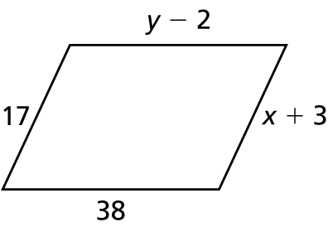2. 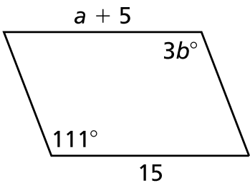

 3. 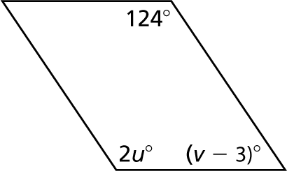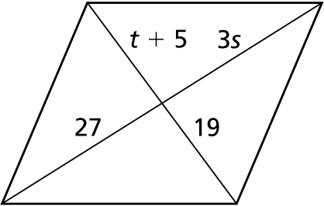4.

5. Find the coordinates of the intersection of the diagonals of the parallelogram   
with vertices 

In Exercises 6 and 7, three vertices of are given. Find the coordinates of the remaining vertex.

 6.  7. 

8. The measure of one interior angle of a parallelogram is more than two   
times the measure of another angle. Find the measure of each angle of the parallelogram.

Name Date

Practice B

7.2

In Exercises 1–4, find the value of each variable in the parallelogram.

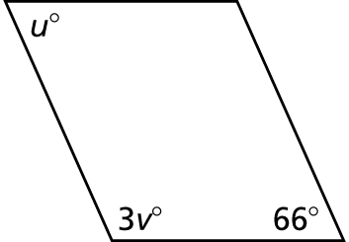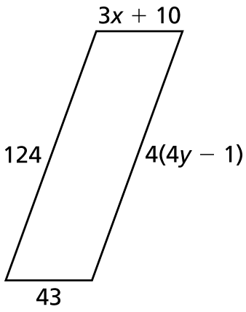 1. 2.

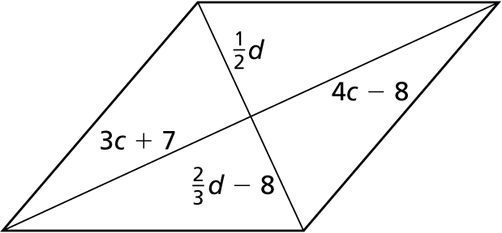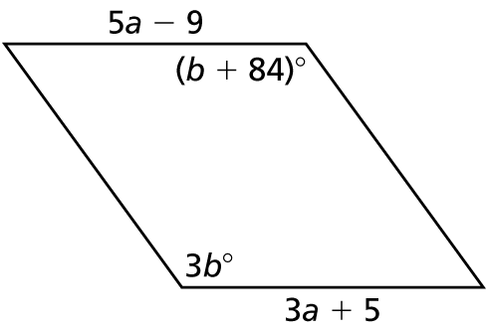 3. 4.

5. Find the coordinates of the intersection of the diagonals of the parallelogram with  
vertices 

6. State whether each statement is *always, sometimes,* or *never* true for a parallelogram*.* Explain your reasoning.

a. The opposite sides are congruent.

b. All four sides are congruent.

c. The diagonals are congruent.

d. The opposite angles are congruent.

e. The adjacent angles are congruent.

f. The adjacent angles are complementary.