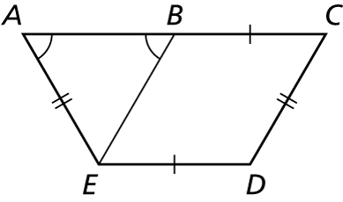Name Date

Practice A

7.3

In Exercises 1 and 2, state which theorem you can use to show that the quadrilateral is a parallelogram.

1. 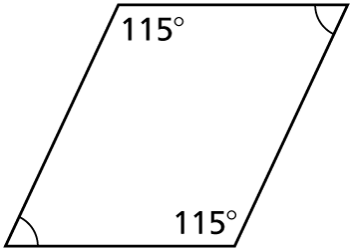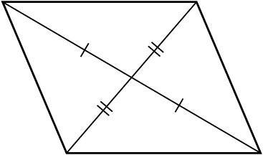 2.

In Exercises 3 and 4, find the value of *x* that makes the quadrilateral a parallelogram. State the theorem you used.

 3. 4. 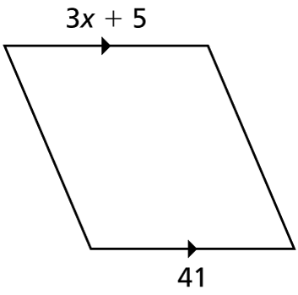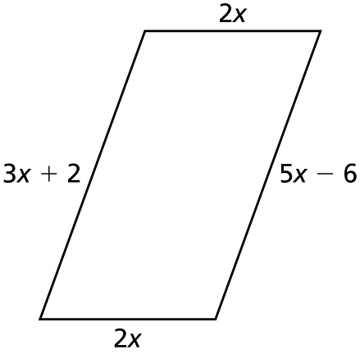

In Exercises 5, graph the quadrilateral with the given vertices in a coordinate plane. Then show that the quadrilateral is a parallelogram.

5. 

6. Use the diagram to write a two-column proof.

Given: 



Prove: *BCDE* is a parallelogram.

Name Date

7.3

puzzle

Puzzle Time

What Kind Of Ship Can Last Forever?

Circle the letter of each correct answer in the boxes below. The circled letters will spell out the answer to the riddle.

Complete the sentence.

1. If both pairs of opposite sides of a quadrilateral are ___________, then the quadrilateral is a parallelogram.

2. If both pairs of opposite angles of a quadrilateral are congruent, then the quadrilateral is a __________.

3. If one _____ of opposite sides of a quadrilateral are congruent and parallel,   
then the quadrilateral is a parallelogram.

4. If the diagonals of a quadrilateral ______ each other, then the quadrilateral   
is a parallelogram.

5. A quadrilateral is ________ a parallelogram.

Name the correct theorem number or give the correct value that 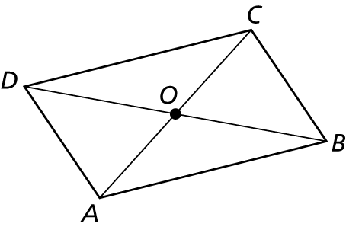  
would make the figure a parallelogram.

6. Given  find 

7. Given    
indicate the theorem number that makes it a parallelogram.

8. 

9. 

10. 

|  |  |  |  |  |  |  |  |  |  |
| --- | --- | --- | --- | --- | --- | --- | --- | --- | --- |
| F | A | R | O | R | N | I | M | S | E |
|  |  | always | equal | congruent | side | sometimes |  |  | parallelogram |
| I | G | N | F | D | S | H | E | I | P |
| supplementary |  | pair | intersect |  |  | bisect |  |  |  |