**Name _________________________________Period ______ Triangle Similarity by AA**

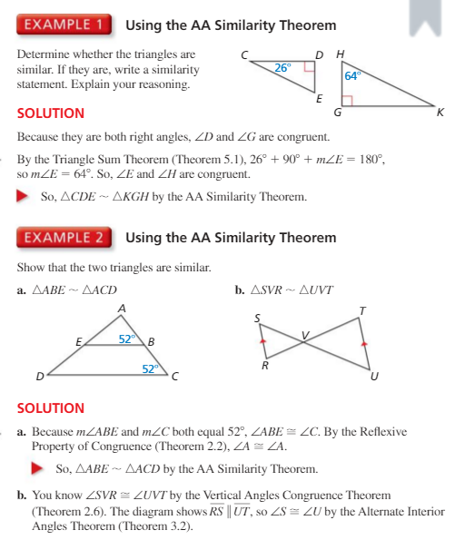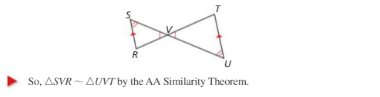

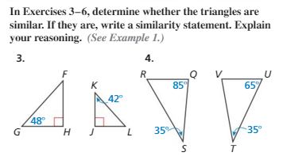

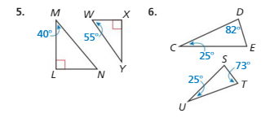

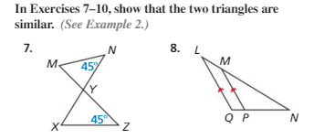

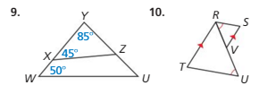

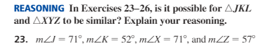

**J**



**L**

**K**

**X**



**Z**

**Y**

