Name _______________________________________ Period _____ 8.3 SSS and SAS Similarity

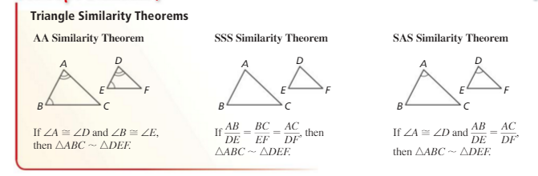

**Using SSS Similarity**

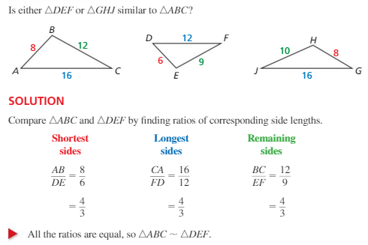

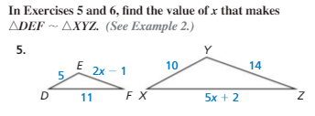

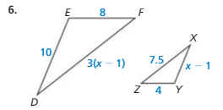

**Using SAS Similarity**

**If you already have a pair of congruent angles in two triangles, you only need to prove that 2 pairs of sides are proportional**

