Algebra in Squares and Rectangles Name ________________________ Period ______
Find the measures of the angles:
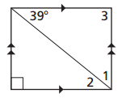
$$∠ 1=$$
$$∠ 2=$$
$$∠ 3=$$

