Name: __1-3 5 8 9-15 17-20 Notes_______ Date: _________________ Period: ________

Geometry Test 8 Review

1. Two numbers are in the ratio . If the sum of the numbers is 84, what is the smaller number?
2. Solve for *x*.

a)  b) 

1. Solve for *x*.

a)  b) 

1. Find the ratio of *x* to *y*.



1. If Δ*GUN* ~ Δ*POW*, complete the proportion:



1. The Eagle Nebula is about 4.9 million light years across; however our own solar system is only 0.0025 light years across. If you see a picture of the nebula that is 140 mm across, how large would a picture of the solar system be on the same scale?
2. The large sculpture of Sam Houston in Hunstville, Texas was constructed on a scale of . If Sam Houston was 2 m tall, how tall is the statue?
3. If the two polygons below are similar, find the length of the missing side.

*x*

15

3

9

1. Δ*TUV* ~ Δ*MLV* by ______.
2. 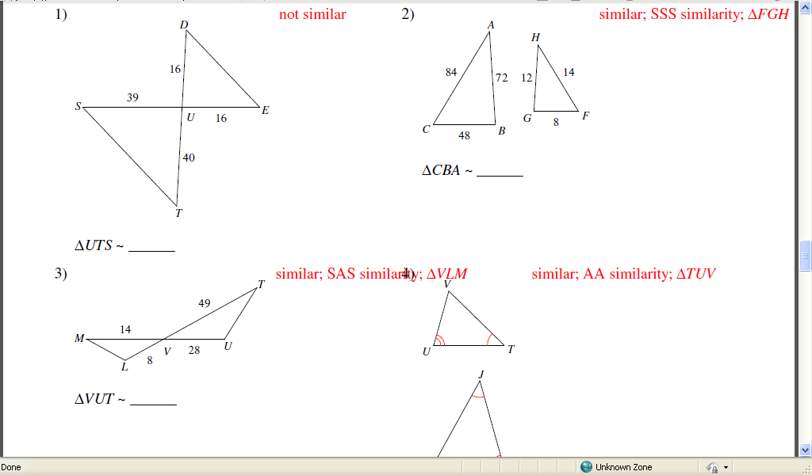AA~
3. SSS~
4. SAS~
5. Not similar
6. What should *AC* be in order for the triangles to be similar by SSS~?



1. If *ED* = 12, what is the length of *VU*?

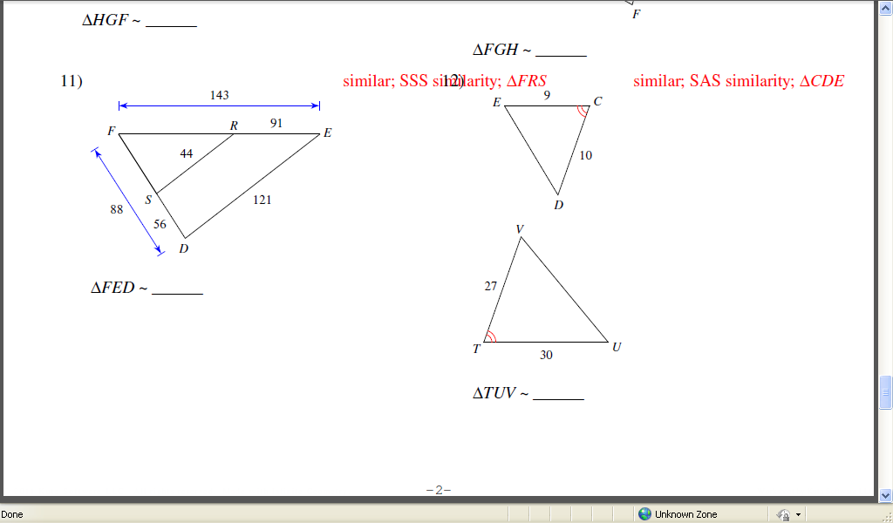

1. Based on this map of a section of El Paso, how long is Dyer St. between Hercules Ave. and Trans Mountain Rd.?



1. In the diagram of Δ*SAE*, , *SA* = 28, *SP* = 8, *CE* = 10. Find *AC*.

*S*

*A*

*P*

*E*

*C*

1. In the figure below, find the value of *x*.

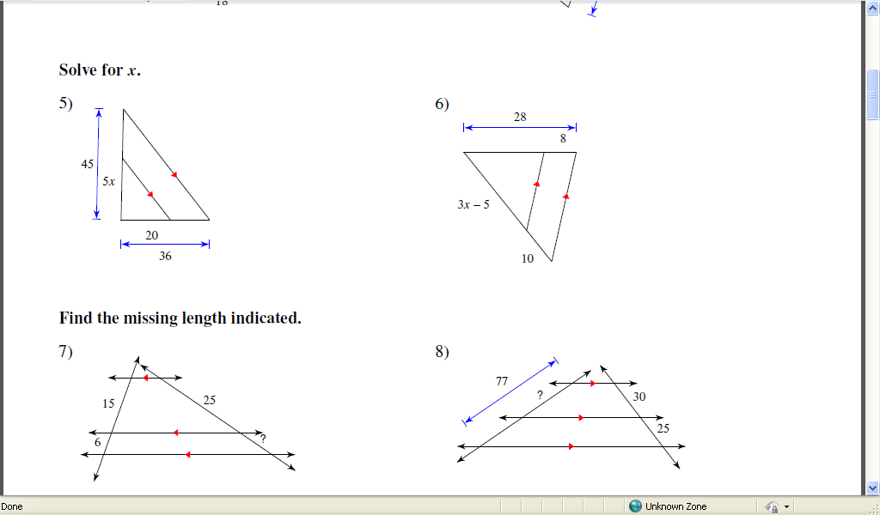

9

2*x*–10

6

4

1. Sean used a mirror and a yard stick to find the height of the downtown Christmas tree. His eyes are 70" above the ground; he spotted the top of the tree in the mirror when he was 20" away from the mirror and the mirror was 8 feet away from the tree. How tall is the tree in feet?

*x*

70"

8'

20"

1. Beth was curious how tall a billboard was, so she measured her shadow and compared it to the billboard’s shadow. Her shadow was 24" long at the same time the billboard’s shadow was 108". If her height is 5'4", what is the height of the billboard?
2. Under a dilation, triangle *A*(0,0), *B*(0,4), *C*(6,0) becomes triangle *A'*(0,0), *B'*(0,10), *C'*(15,0).  What is the scale factor for this dilation?

18.

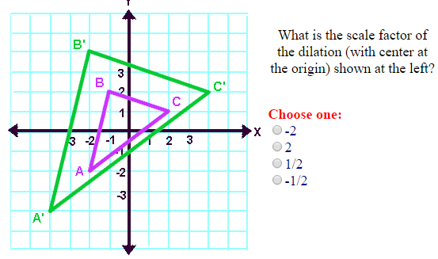

The test calls scale factor 3:5 or a similar form. What should I do?

Find scale factor between two similar figures.

Find the coordinates of a point after dilation.

Find the retio of the perimeters of two figures. What is the trick?

Find a missing side in two similar figures. The test has this several times and asks differently each time. LIKE: Find the missing side. OR What does x have to be to make the two figures similar?

What are three methods to determine Similarity?

USE the names of triangles to match up their parts.

There are 2 triangle proportionality questions. One angle bisector proportionality question.

19.

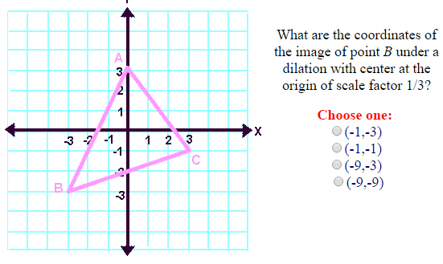

20.

