**Name ____________________________ Period_____ Review Questions for Bundle 8 and 9**

**Chapter 4.5 Dilations**

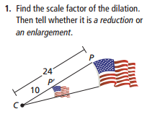

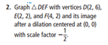

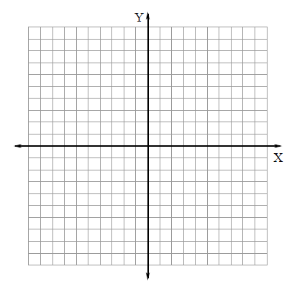

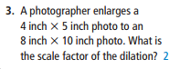

**Chapter 4.6 Similarity and Transformations**

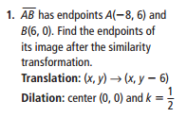



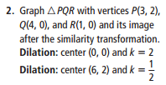



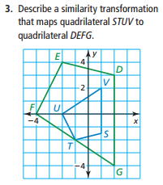

**Chapter 8.1 Similar Polygons**

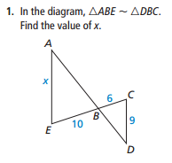

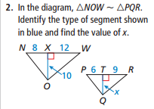

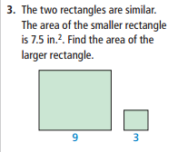

**Chapter 8.2 AA Similarity**

Show how these triangles are similar and write a similarity statement.

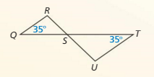

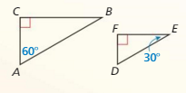

**Chapter 8.3 SSS and SAS Similarity**

Show how these triangles are similar and write a similarity statement.

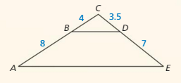

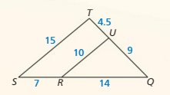

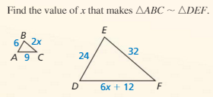

**Chapter 8.4 Proportionality Theorems** (Parallel lines in similar figures, Angle Bisector Theorem)

Show how AB is II to CD.

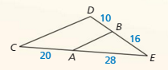

Show how AB is II to CD.

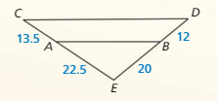

Find the length of YB

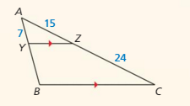

Find the length of AB.

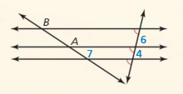

Find the length of AB.

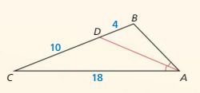

Find the length of ***p***.

