Name: ________________________________________ Date: _________________ Period: _____

Geometry Bundle 7 Test REVIEW

**Match the formulas.**

_______ 1. sum of the interior angles of a polygon A. *n* – 3

_______ 2. sum of the exterior angles of a polygon B. *n* – 2

_______ 3. measure of one interior angle of a regular polygon C. (*n* – 2)(180)

_______ 4. measure of one exterior angle of a regular polygon D. 

_______ 5. number of diagonals drawn from one vertex E. 360

_______ 6. number of triangles formed by diagonals from one vertex F. 

7. What is the sum of the measure of the interior angles of a 19-gon?

8. What is the measure of one interior angle of a regular 24-gon?

9. What is the sum of the measures of the exterior angles of any polygon?

10. What is the measure of one exterior angle of a regular 18-gon?

11. The sum of the measures of the interior angles of a convex polygon is 3780°. Classify the polygon by the number of sides.

12. Find the value of x. 13. Solve for x.

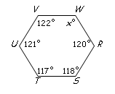

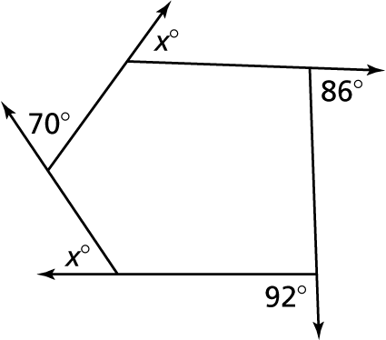

14. If the measure of one of the angles of a rectangle is (6x+24)°, then find the value of x.

15. If the length of one of the diagonals of a rectangle is 52 inches, then what is the length of the other?

16. In parallelogram *MLHS*, m∠*M* = (8*x*–20)° and m∠*L* = (5*x*+10)°. Find the value of *x*.

*L*

*H*

*M*

*S*

17. In parallelogram *ABCD*, the two diagonals intersect each other at point *M*. If *AC* = 25 inches, then what is the length of ?

*M*

*B*

*C*

*D*

*A*

D

C

B

A



Q

18. Rhombus ABCD has a perimeter of 72 inches. Find the value of *x*.

95°

45°

*A*

*D*

*C*

*B*

19. Find the measure of ∠*A* and ∠*B.*

(12x + 7)°

(15x - 8)°

20. Find the value of x for the following isosceles trapezoid.

21. If *AD* = 3 and *BC* = 17, find *EF*.

***B***

***A***

***C***

***D***

***F***

***E***

*x*

*y*



22. Figure *ABCD* has vertices: *A* (4, 6); *B* (8, 7); *C* (7, 3); *D* (3, 2).

What is the best name for figure *ABCD*?

***Be sure you know and can use all the properties of special quadrilaterals****

**Review previous homework and quizzes**