Name: ________________________________________ Date: _________________ Period: _____

Geometry Bundle 7 Test REVIEW

**Match the formulas.**

__**C**____ 1. sum of the interior angles of a polygon A. *n* – 3

__**E**____ 2. sum of the exterior angles of a polygon B. *n* – 2

___**D**___ 3. measure of one interior angle of a regular polygon C. (*n* – 2)(180)

___**F**___ 4. measure of one exterior angle of a regular polygon D. 

___**A**___ 5. number of diagonals drawn from one vertex E. 360

___**B**___ 6. number of triangles formed by diagonals from one vertex F. 

7. What is the sum of the measure of the interior angles of a 19-gon? (19-2)180 = ?

8. What is the measure of one interior angle of a regular 24-gon? (24-2)180 divided by 24 = ?

9. What is the sum of the measures of the exterior angles of any polygon? 360 degrees

10. What is the measure of one exterior angle of a regular 18-gon? 360 divided by 18 = ?

11. The sum of the measures of the interior angles of a convex polygon is 3780°. Classify the polygon by the number of sides. (n – 2)180 = 3780 Solve for n

12. Find the value of x. 13. Solve for x.

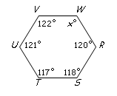

All exterior angles add up to 360.

70 +x +92 +86 + x = 360

Solve for x

Need total degrees in hexagon

(6 sides -2)180 = 720

Now solve for x:

122 +121+117+118+120+x = 720

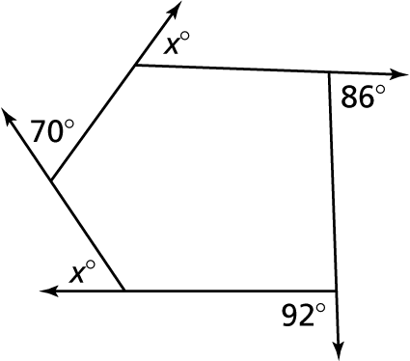

14. If the measure of one of the angles of a rectangle is (6x+24)°, then find the value of x.

Rectangle angles are 90. So 6x +24 = 90 solve for x

15. If the length of one of the diagonals of a rectangle is 52 inches, then what is the length of the other? **Rectangles have congruent diagonals so ……**

16. In parallelogram *MLHS*, m∠*M* = (8*x*–20)° and m∠*L* = (5*x*+10)°. Find the value of *x*.

∠M and ∠L are consecutive angles so they are not congruent…they are ___________ .

They add up to ______.

8x – 20 + 5x + 10 = 180 Solve for x.

*L*

*H*

*M*

*S*

17. In parallelogram *ABCD*, the two diagonals intersect each other at point *M*. If *AC* = 25 inches, then what is the length of ?

Diagonals of parallelograms bisect each other, so MC is exactly what part of AC?

*M*

*B*

*C*

*D*

*A*

D

C

B

A



Q

18. Rhombus ABCD has a perimeter of 72 inches. Find the value of *x*.

A Rhombus sides are all congruent. How many (2x + 6) are there? They add up to what? Solve for x.

95°

45°

*A*

*D*

*C*

*B*

19. Find the measure of ∠*A* and ∠*B.*

The marks on the sides indicate that this is what shape? Which angle is congruent to ∠D? Quadrilaterals interior angles always total 360ᵒ. How many degrees are left for ∠A?

(12x + 7)°

(15x - 8)°

20. Find the value of x for the following isosceles trapezoid.

The base angles on an isosceles trapezoid are congruent. Set them equal and solve for x.

21. If *AD* = 3 and *BC* = 17, find *EF*.

EF is the average of AD and BC.

***B***

***A***

***C***

***D***

***F***

***E***

*x*

*y*



22. Figure *ABCD* has vertices: *A* (4, 6); *B* (8, 7); *C* (7, 3); *D* (3, 2).

B

A

What is the best name for figure *ABCD*?

Plot the points. Decide the shape and write down the slopes of opposite sides to determine if they are parallel.

The slope of AD and BC are 4/1 so they are parallel.

The slope of AB and DC are ¼ so they are parallel.

Now use Pythagorean theorem to find out if opposite sides are congruent to each other. The numbers from slope are the same as the sides of the triangle that helps you find the length of each line. So $a^{2}+b^{2}=c^{2}$ becomes $4^{2}+1^{2}= c^{2}.$

Work all 4 sides for their length. You will find that this is a Rhombus.

D

C

***Be sure you know and can use all the properties of special quadrilaterals****

**Review previous homework and quizzes**